**Sprint 1 Report**

**Product Name:** SummarAIze

**Sprint Completion Date:** April 22, 2025

**Revision Number:** V1.1

**Revision Date:** April 23th, 2025

**Actions to stop doing:**

* Stop sidetracking
* The team should stop sidetracking during scrum meetings, because the meetings go longer than expected and prevent us from talking about other important topics.
* The team should stop procrastinating on tasks, because many times we are dependent on the work of other team members.

**Actions to start doing:**

* The team should start delegating tasks earlier, so that we don’t start accidentally doing tasks other people have started on.
* The team should start creating more thorough task lists during sprint planning, because we end up having to add more tasks in the middle of the sprint if we don’t.

**Actions to keep doing:**

* The team should continue updating the scrum board with tasks they have completed.

**Work completed/not completed:**

* **Work Completed:**
  + **As a student, I need to upload a research paper PDF through an accessible website and get an accurate summary of the paper so I can understand the main points without reading the entire paper.**
    - Task 1: Get the Open AI API (1 hour)
    - Task 2: Implement GPT Wrapper (2 hours)
    - Task 3: Set up Github (30 min)
    - Task 4: Create a spreadsheet with API pricing (to split costs) (30 min)
    - Task 5: Create the Wireframe (1 hr)
    - Task 6: Code a basic UI with PDF upload (2 hours)
    - Task 7: Create a React web application (30 min)
    - Task 8: Create a place for backend to go (30 min)
    - Task 9: Adding title and basic CSS formatting (1 hr)
    - Task 12: Connect frontend to backend (1 hr)
  + **As a user, I want to indicate that I have no background knowledge on the research topic and receive a detailed literature review so that I can learn more about the subject.**
    - Task 1: Add toggle for background knowledge or not; Advanced/Basic (30 min)
    - Task 2: Generate the simplified explanations for Basic user using Open AI API (2 hours)
* **Work Incomplete:**
  + None
* **Work Completion Rate: 100%**
* **User Stories Completed: 2**
* **Total Estimated Time: 10 hours**
* **Total Number of Days: 14 days**

**Scrum Board:**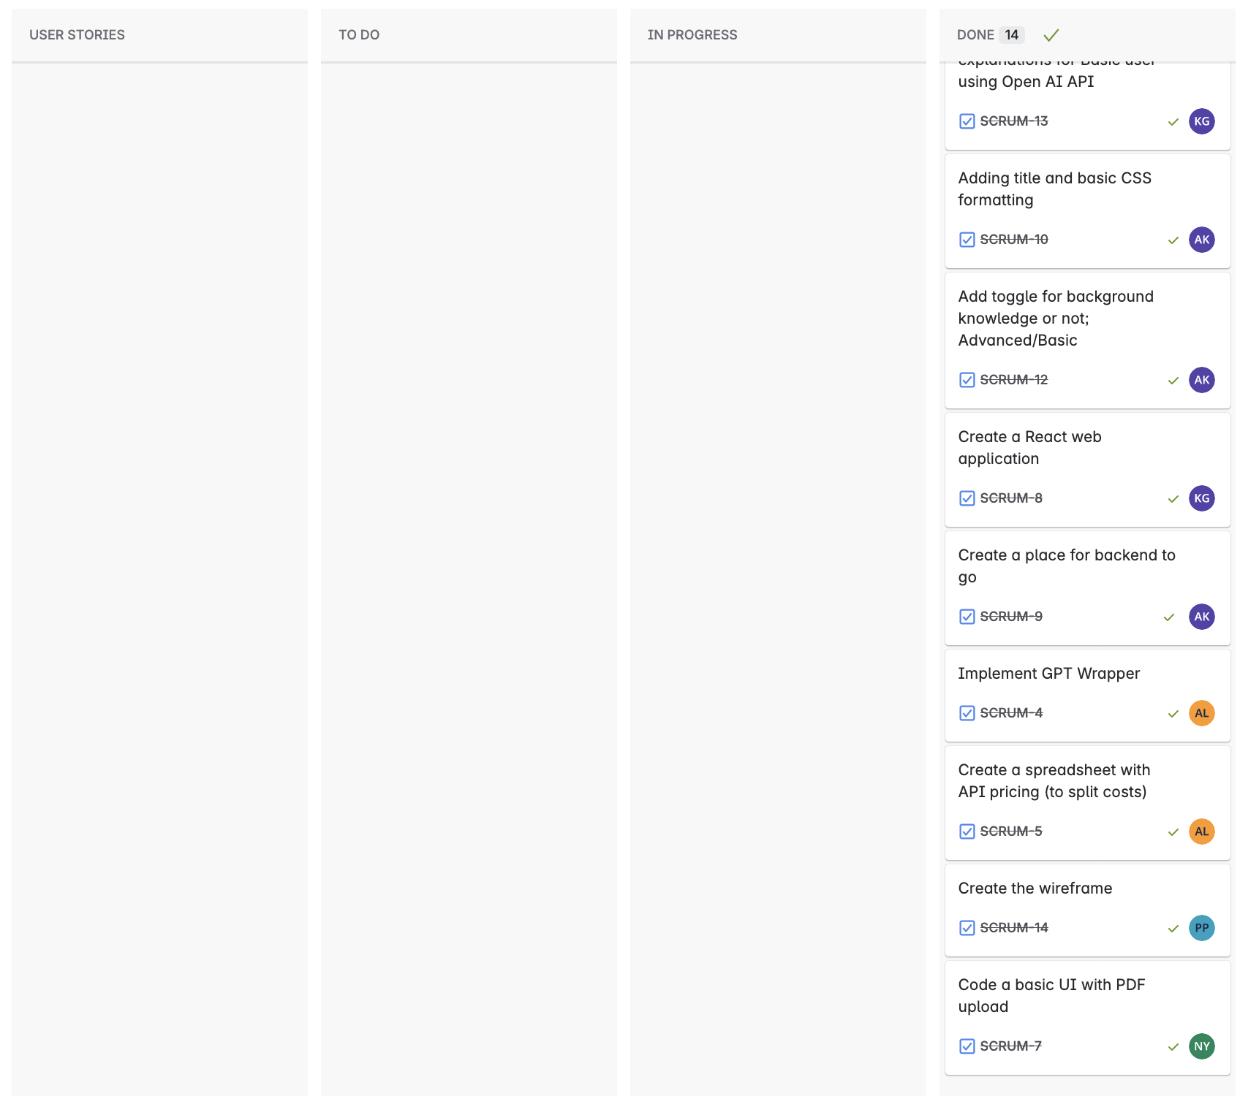

**Burn-up Chart:**

